Subversion (SVN) Guide

Subversion is an open source version control system. You can download the client from [http://tortoisesvn.net](http://tortoisesvn.net/downloads.html)

### Setting up SVN

1. Create a project directory on your local drive i.e. C:\AIE\svn\2012_year1
2. **Checkout** the repository to your project directory by right clicking on the folder and clicking on SVN Checkout

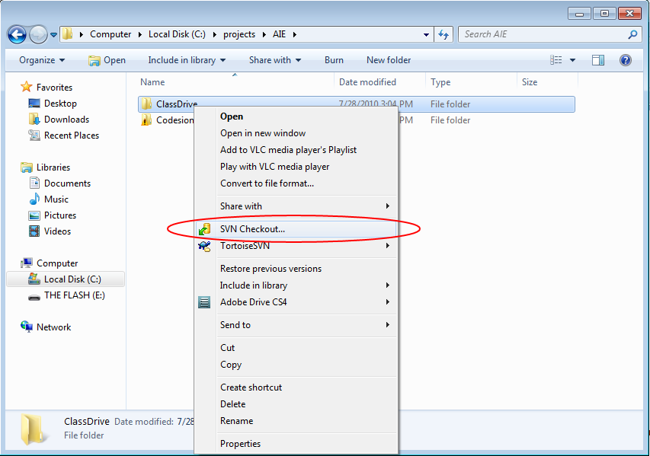

1. Enter the url for the repo (ask your teacher if one exists) and click ok.

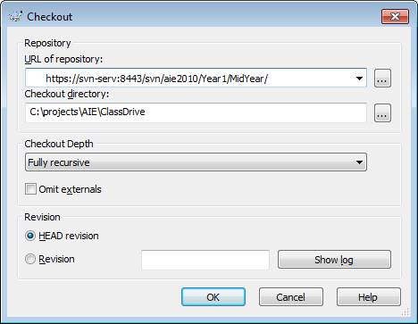

1. You will be asked to enter your username and password. Click Save authentication and click OK
2. It will commence to pull down all the files in the repo

### Using SVN

***Getting files from the server***

To do this we right click on our workspaces root directory and go SVN Update. This will grab all the latest files from the server.

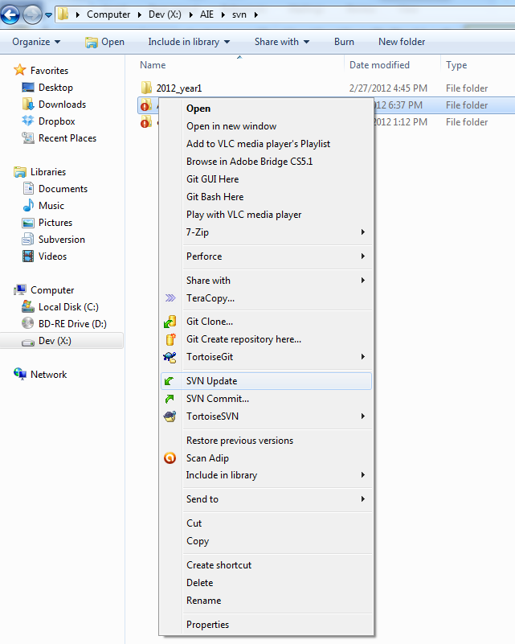

***Adding files from the server***

To add files and folders to the server we right click on the files we want and go TortoseSVN\Add. 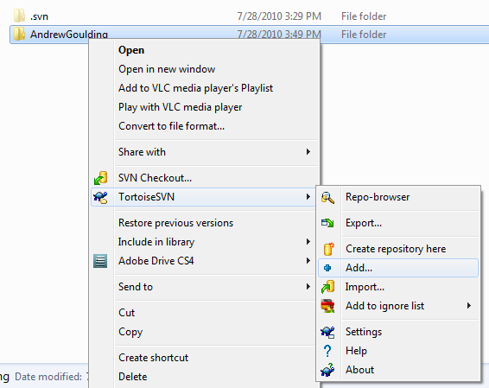

***Submitting changes to the server***

Once you are ready to submit your changes you right click the files, right click on the folder again and go SVN Commit

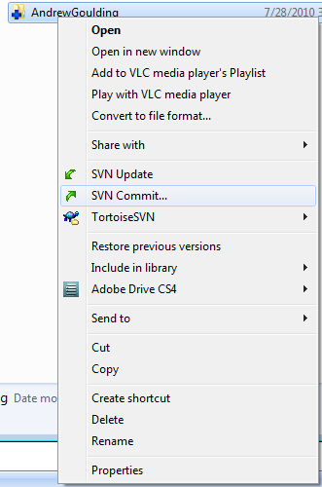

A little dialogue box will come up and ask for a description of the changes you made and what files you are sending to the server. **YOU MUST** provide a comment. The more descriptive you can be the better. Once you are done click OK.

